The design which applied

1. This the component build
2. ApiGateWay
3. Employee
4. EmpMapper – ibatis dao
5. EmployeeMsApplication
6. EmpService which will be used by the controller to persist the record
7. This db design
8. **CREATE TABLE** EMPLOYEE  
   (  
    **id** *INTEGER* AUTO_INCREMENT **PRIMARY KEY**,  
    **NAME** *VARCHAR* (100),  
    POSITION *VARCHAR* (100)  
   );

**INSERT INTO** EMPLOYEE(**NAME**,POSITION) **VALUES**('ALI','MANAGER');  
**INSERT INTO** EMPLOYEE(**NAME**,POSITION) **VALUES**('JACK','DEVELOPER');  
**INSERT INTO** EMPLOYEE(**NAME**,POSITION) **VALUES**('MA','DEVELOPER');  
**INSERT INTO** EMPLOYEE(**NAME**,POSITION) **VALUES**('MA','TECHNICAL MANAGER');

1. You can assess the db console using this setting

<http://localhost:8888/db>

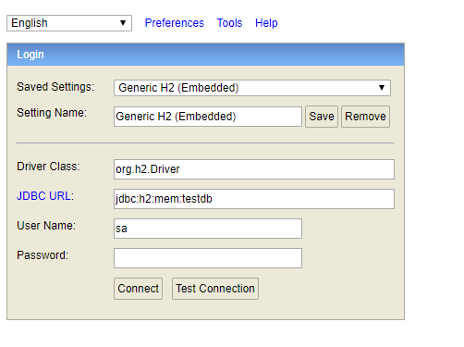

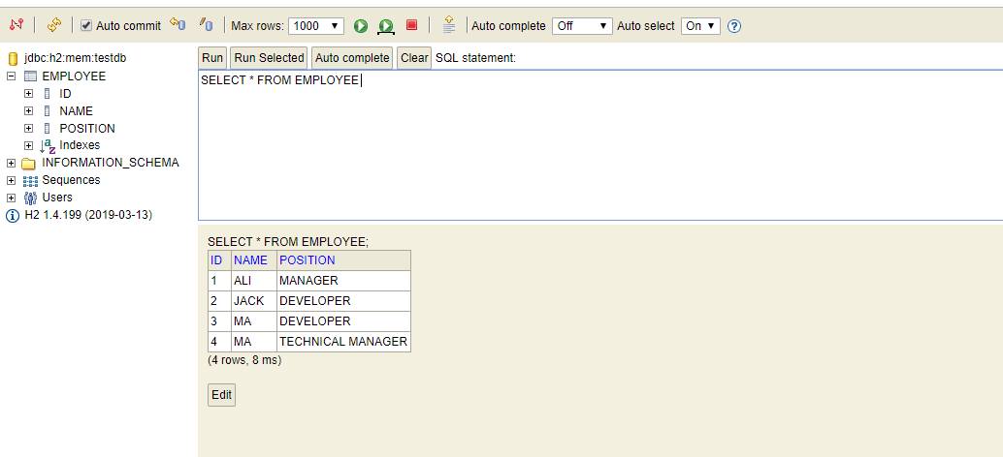

1. The test case was exactly was written spring-boot, later I have changed to camel route
2. The application can be start using this approach in intelj

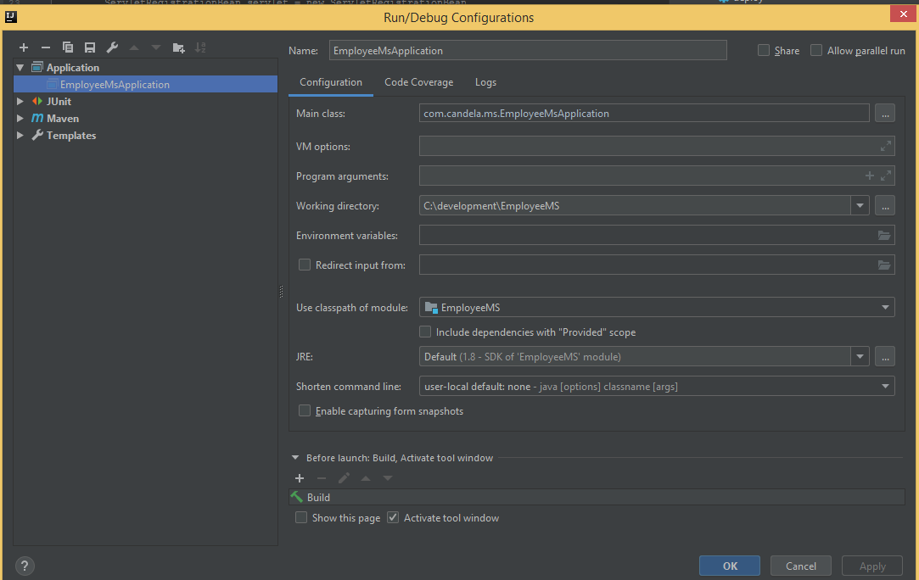

Please run mvn:install to pull the jar from the repository.

1. The camel has been set for the location, get the Employee

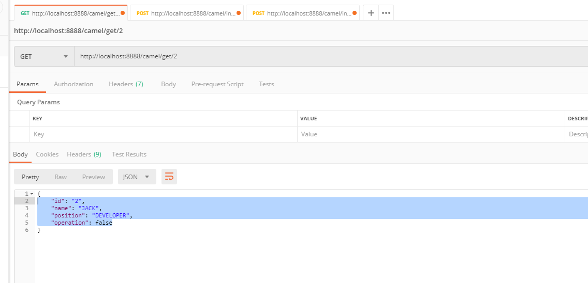

1. This is inserted

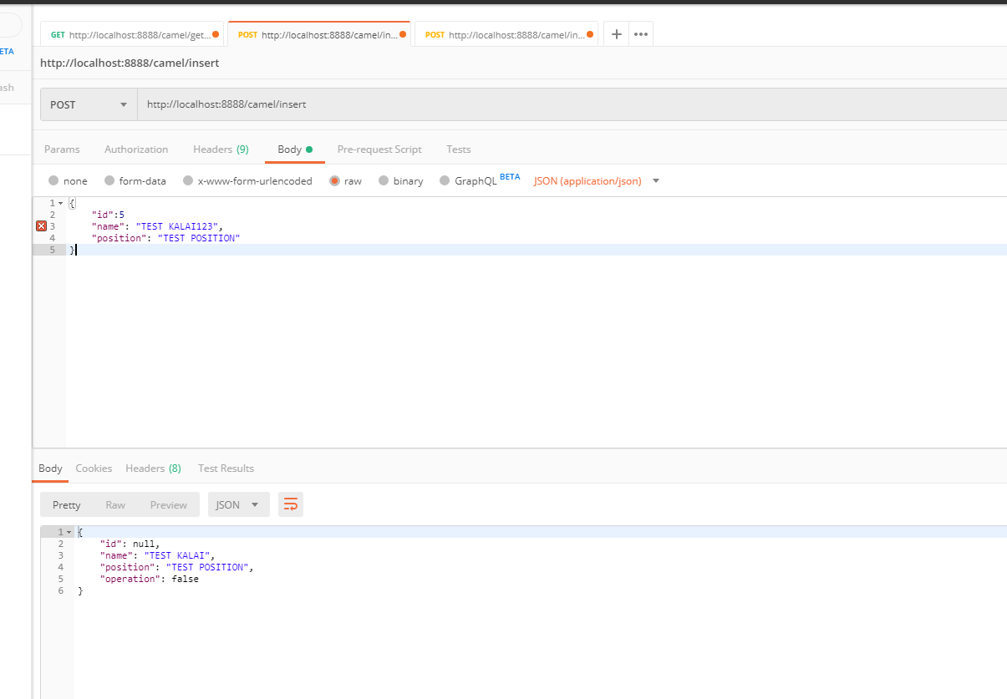

1. Update is using this

